1



CLIENT INFORMATION FORM

THANK YOU FOR CHOOSING US TO CARE FOR YOUR PETS.

**OWNER**

YOUR NAME: _________________________________________________________ □ MR. □ MRS. □ MS.

ADDRESS: ________________________________________________ ZIP CODE: _______________________

CELL PHONE: _______________________________ ADDTL’ NUMBER: ______________________________

EMAIL ADDRESS: ___________________________________________________________________________

**CO-OWNER • SPOUSE • SIGNIFIGANT OTHER • RELATIVE**

NAME: _________________________________________________________________

CELL PHONE: ___________________________________________________________

PLEASE TELL US YOUR PREFERRED METHOD OF CONTACT:

□ PHONE □ TEXT □ EMAIL

How did you hear about Jonesville Animal Hospital?

❑ Location ❑ Google ❑ Our Website ❑ Facebook • Instagram

❑ Referred from: **______________________________________________________**

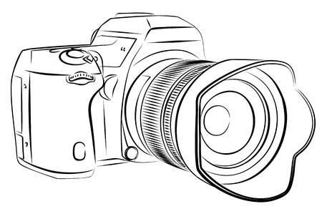

PHOTO CONSENT:

**WE LOVE SOCIAL MEDIA!**

We would love to share photos of your pet on our social media pages and website. Your name and personal information will never be shared.

❑ I AUTHORIZE Jonesville Animal Hospital to take and share photos of my pet.

❑ I DO NOT authorize this.

PAYMENT IS DUE WHEN SERVICES ARE PROVIDED.

Client signature: ___________________________________ Date: _______________